**HTML ASSIGNMENTS:**

1. **Build a survey form page using html, apply basic validations on each of the texfields for length.**

**[Optional] JS to validate the form and collect the data and display it in a table**

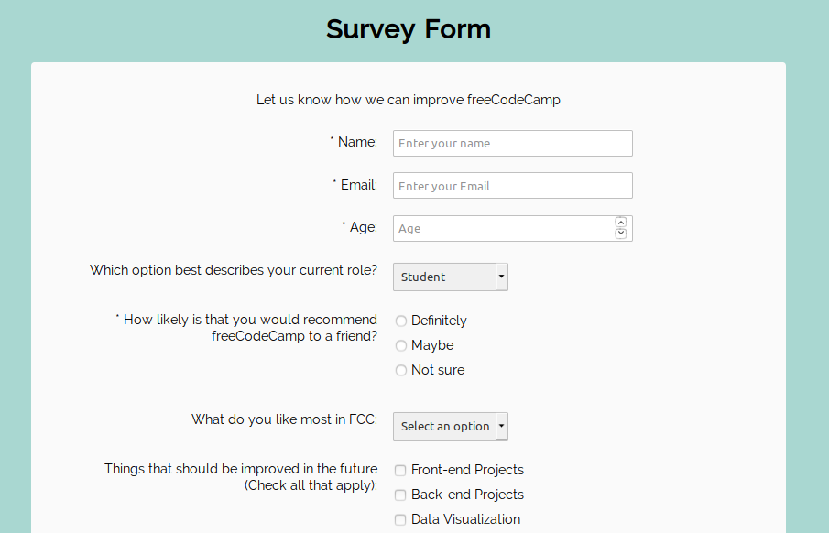

1. [**Build a Technical Documentation Page**](https://learn.freecodecamp.org/responsive-web-design/responsive-web-design-projects/build-a-technical-documentation-page/)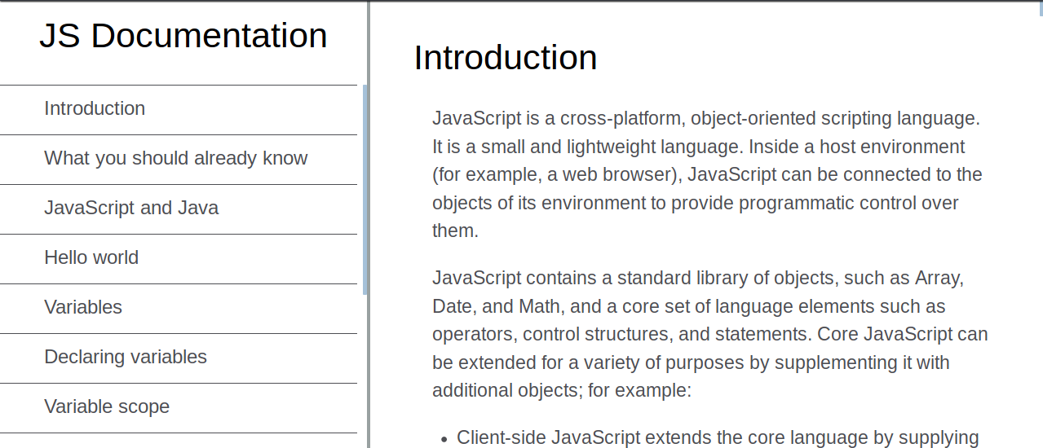
2. [**Build a Personal Portfolio Webpage**](https://learn.freecodecamp.org/responsive-web-design/responsive-web-design-projects/build-a-personal-portfolio-webpage/)

